FOR IMMEDIATE RELEASE

Indy Modern Quilt Guild hosts inaugural exhibition at Garfield Park Arts Center
July 2, 2021 — Showcasing the talents of greater Indianapolis quilters, the Indy Modern Quilt Guild debuts its Exhibition 2021 at Garfield Park Arts Center on July 2-31, 2021.

The show features around 50 works from over 20 artists, highlighting various aspects of modern quilting including minimalism, asymmetry, improvisational piecing, negative space, bright and graphic pallets, and modern traditionalism.

“Modern quilting brings a fresh perspective to traditional quilting with fun and bright colors, bold graphic prints, and simplicity in layout and design,” said Sacha Brady, Exhibition coordinator and IMQG member. “The quilts demonstrate a colorful and wide variety of styles, approaches, and designs.”

This is the fourth quilt show for the guild displaying the interpretations of the conventions of modern quilting in their pieces, but the largest show IMQG has undertaken.

“We are excited for our new partnership with the Indy Modern Quilt Guild and to introduce our audience to the concept of modern quilting.” said Kavita Mahoney, Manager of the Garfield Park Arts Center. “This exhibition will be a unique opportunity for guests to engage with the medium of quilting in a completely different way.”

The Indy MQG Exhibition 2021 will be open Tuesdays through Saturdays in July from 10 a.m. to 5 p.m. at Garfield Park Arts Center on Conservatory Drive in Indianapolis. Guild members will be on hand opening night, July 2 from 6 p.m. to 8 p.m., to mingle with guests and answer questions.

Started as an online forum in 2010 for modern sewists to connect and create together, no matter ages, skill levels, or quilting backgrounds, the guild joined the global Modern Quilt Guild organization in 2013.
IMQG plans to resume face to face meetings and programing in the coming months.

For more information on our upcoming programming, where our meetings will be held in the future, and how to join the Indy Modern Quilt Guild, please visit: www.indymqg.com.

WHAT: Indy Modern Quilt Guild Exhibition 2021
WHEN: July 2-31, 2021
WHERE: Garfield Park Arts Center, Third Floor Gallery, 2432 Conservatory Drive, Indianapolis, IN 46203
ADMISSION & PARKING: Free, masks required

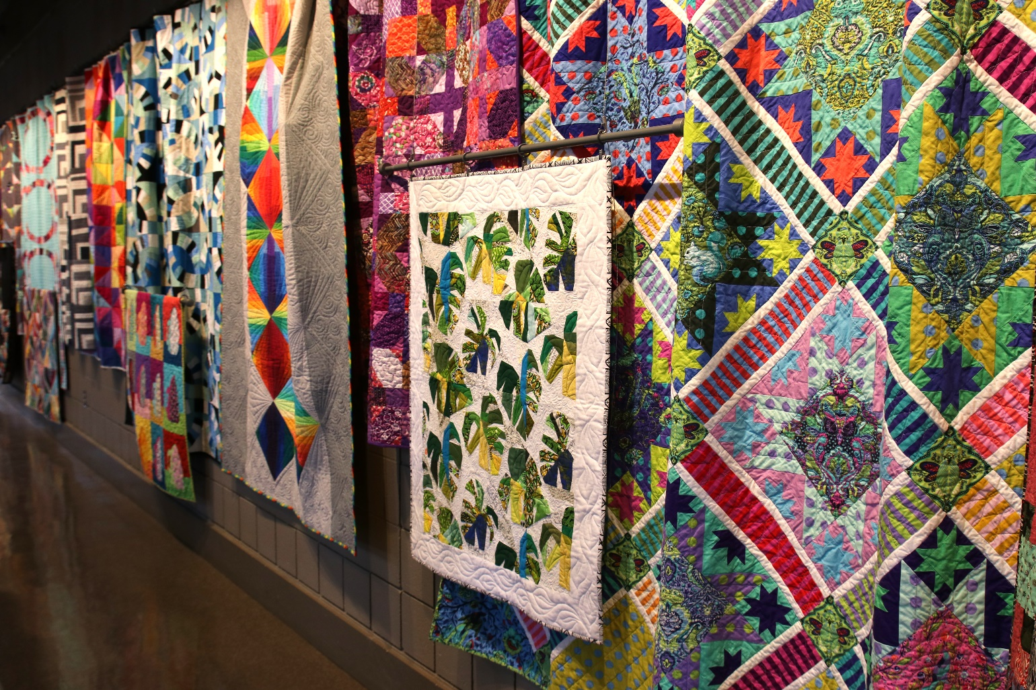

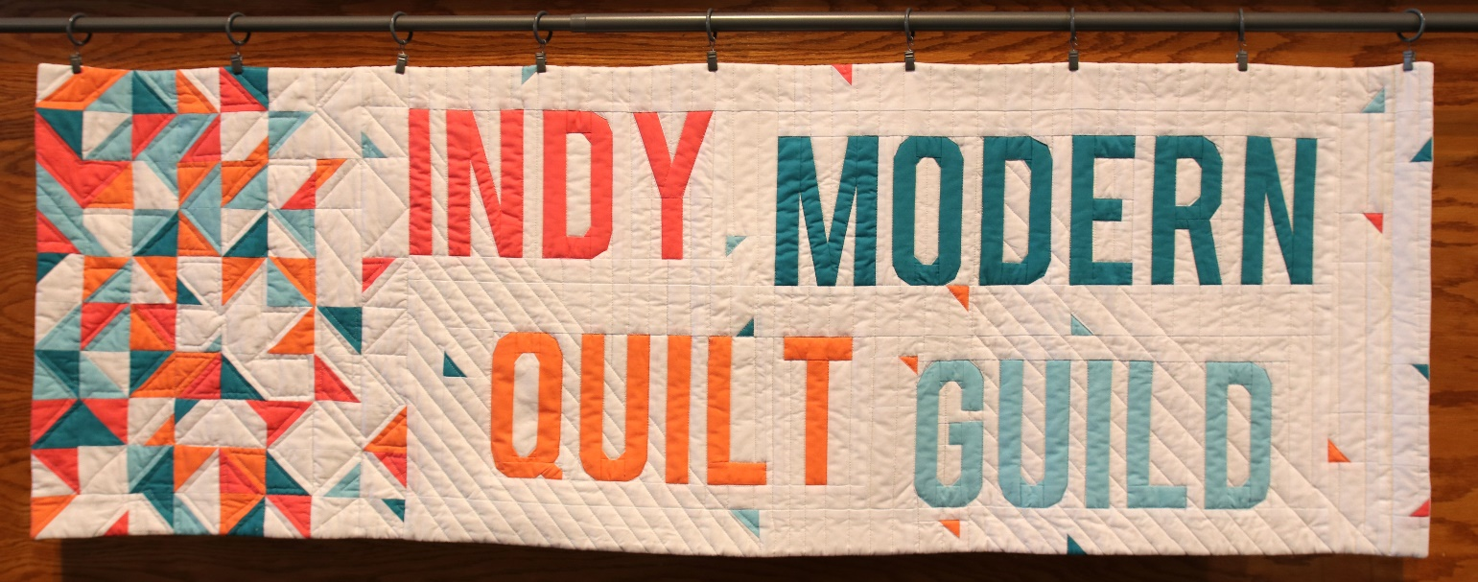
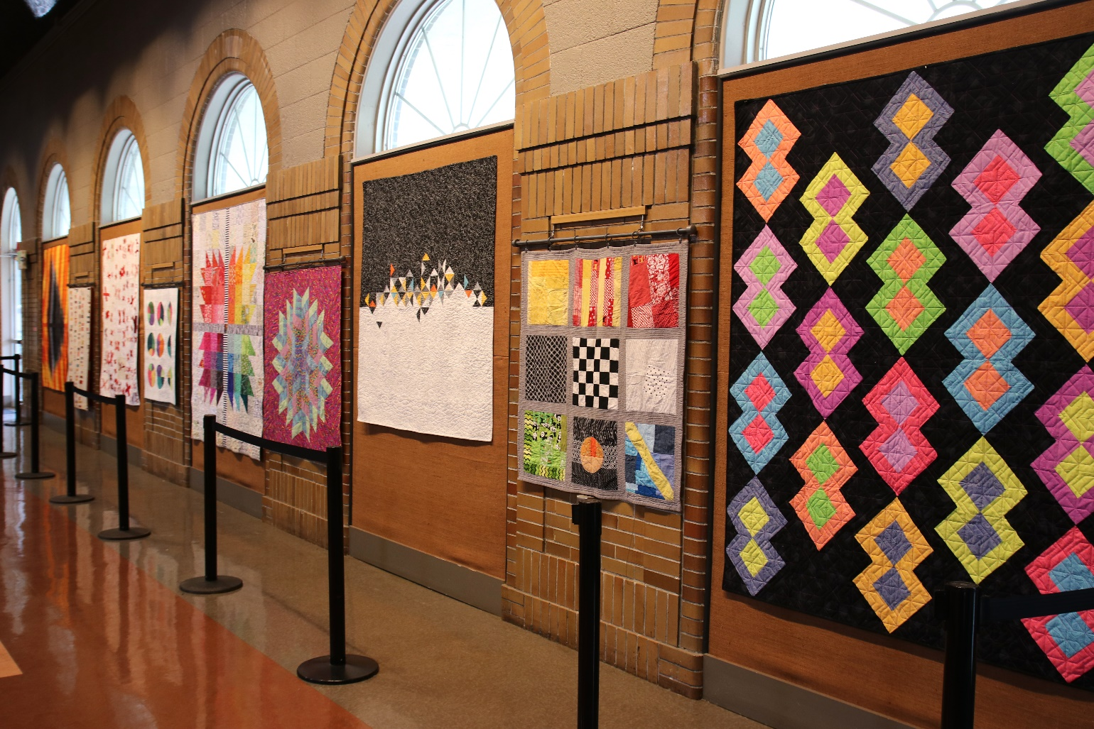

Photos by Sydney Davis Photography

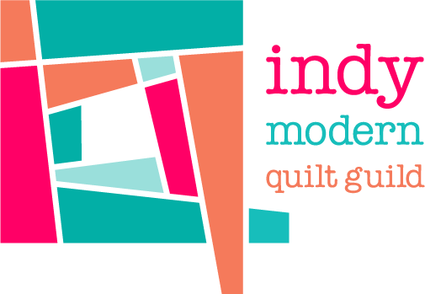
About the Indy Modern Quilt Guild
Started in 2010, the Indianapolis Modern Quilt Guild (IMQG) is a group of modern sewists of all ages, skill levels, and quilting backgrounds who connect and create together. The Guild is part of the Modern Quilt Guild, a 501(c)(3) nonprofit with over 150 guilds and 10,000 members worldwide.

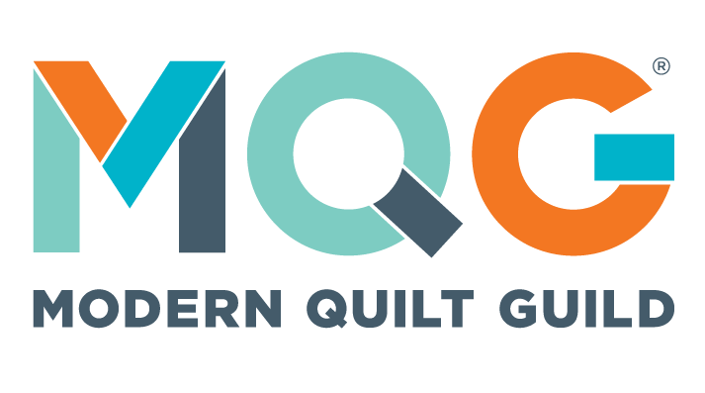
About the MQG
The Modern Quilt Guild is made up of more than 150 guilds and 10,000 members around the world. Their mission is to support and encourage the growth and development of modern quilting through art, education, and community. Learn more at themodernquiltguild.com.

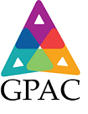
About the Garfield Park Arts Center
The Garfield Park Arts Center, part of Indy Parks & Recreation, engages visitors in diverse, artistic and cultural exhibitions, arts classes, and special events. It features performing arts spaces, visual arts galleries, classrooms, and a literary arts library. The mission of the Garfield Park Arts Center strives to inspire and build a community of arts learners, leaders, and organizations. Indy Parks’ mission is to connect communities by providing places and experiences that inspire healthy living, social engagement, and a love of nature.

###

For additional information contact: Sacha Brady, Exhibition Chair, Indy Modern Quilt Guild, indymodernquiltguild@gmail.com, indymqg.com.

